**Project Design Phase – I**

**Proposed Solution**

|  |  |
| --- | --- |
| Date | 19 September 2022 |
| Team ID | PNT2022TMID14584 |
| Project Name | Customer Care Registry |
| Maximum Marks | 4 Marks |

**Solution Architecture:**

Solution architecture is a complex process – with many sub-processes – that bridges the gap between business problems and technology solutions. Its goals are to:

• Find the best tech solution to solve existing business problems.

• Describe the structure, characteristics, behaviour, and other aspects of the software to project stakeholders.

• Define features, development phases, and solution requirements.

• Provide specifications according to which the solution is defined, managed and delivered.

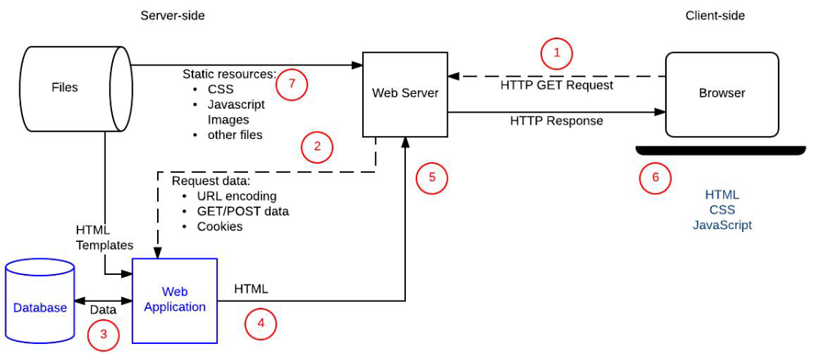**Technical Architecture:**

**Technological Architecture:**

